

Behaviour Policy
Ashburnham Community School

Policy to be read in conjunction with Governor’s behaviour statement.

Federation | No
Statutory | Yes
Staff member | Paul Cotter
Governor | Jodie Terry
Committee | Standards
Full Governing Body | No
Last amendment date | Spring 2018
Renewal date | Spring 2020
Renewal cycle | Every 2 years

Contents
POLICY STATEMENT 2
1. Aims 3
2. Legislation and statutory requirements 3
3. Definitions 3
4. Bullying 4
5. Roles and responsibilities 4
6. PRACTICE 5
7. Rewards and sanctions 6
Rewards 6
Consequences 6
8. Behaviour management 8
i) Individualised behaviour plan (IBP) in Appendix 4 9
9. Pupil transition 10
10. Parents and carers 10
11. Training 10
12. Monitoring arrangements 10
13. Links with other policies 11
Appendix 1: Governors’ statement of behaviour principles 12
Appendix 2: Behaviour chart 13
Appendix 3: Exemplar class contract 14
Appendix 4: Individual behaviour plan proforma 15
Appendix 5: Red card form 16
Appendix 6: Restraint incident form 17

…………………………………………………………………………………………………………………………….

POLICY STATEMENT

The Fox Federation (‘The Federation’) takes its responsibility of care for its students seriously and believes that everyone within the school community has the right to be safe, trusted, respected to enable them to fully access the curriculum and attain their maximum potential. This premise spans many areas; classrooms, playground and off site on curriculum/learning visits (museum trips & weekly swimming lessons) and school journeys.

Across The Federation we expect the highest standards of behaviour at all times from all our pupils in line with each individual school’s values and code of conduct.

If you require this policy in another language, this can be arranged.

This policy is available to all parents either in hard copy or from our school website.

1. Aims
This policy aims to:
- Provide a consistent approach to behaviour management
- Define what we consider to be unacceptable behaviour, including bullying
- Outline how pupils are expected to behave
- Summarise the roles and responsibilities of different people in the school community with regards to behaviour management
- Outline our system of rewards and sanctions

2. Legislation and statutory requirements
This policy is based on advice from the Department for Education (DfE) on:
- Behaviour and discipline in schools
- Searching, screening and confiscation at school
- The Equality Act 2010
- Use of reasonable force in schools
- Supporting pupils with medical conditions at school
It is also based on the special educational needs and disability (SEND) code of practice.
In addition, this policy is based on:
- Section 175 of the Education Act 2002, which outlines a school’s duty to safeguard and promote the welfare of its pupils
- Sections 88-94 of the Education and Inspections Act 2006, which require schools to regulate pupils’ behaviour and publish a behaviour policy and written statement of behaviour principles, and give schools the authority to confiscate pupils’ property
- DfE guidance explaining that maintained schools should publish their behaviour policy online

3. Definitions
Misbehaviour is defined as:
- Disruption in lessons, in corridors between lessons, and at break and lunchtimes
- Non-completion of classwork
- Poor attitude

Serious misbehaviour is defined as:
- Repeated breaches of the school rules
- Any form of bullying
- Sexual assault, which is any unwanted sexual behaviour that causes humiliation, pain, fear or intimidation
- Vandalism
- Theft
- Fighting
- Smoking
- Racist, sexist, homophobic or discriminatory behaviour
- Possession of any prohibited items.

4. Bullying
Bullying is defined as the repetitive, intentional harming of one person or group by another person or group, where the relationship involves an imbalance of power.
Bullying is, therefore:
- Deliberately hurtful
- Repeated, often over a period of time
- Difficult to defend against

Bullying can include:

Type of bullying | Definition
Emotional | Being unfriendly, excluding, tormenting
Physical | Hitting, kicking, pushing, taking another’s belongings, any use of violence
Racial | Racial taunts, graffiti, gestures
Sexual | Explicit sexual remarks, display of sexual material, sexual gestures, unwanted physical attention, comments about sexual reputation or performance, or inappropriate touching
Direct or indirect verbal | Name-calling, sarcasm, spreading rumours, teasing
Cyber-bullying | Bullying that takes place online, such as through social networking sites, messaging apps or gaming sites

Details of our school’s approach to preventing and addressing bullying are set out in our anti-bullying policy.

5. Roles and responsibilities

5.1 The governing board
The Governing body is responsible for reviewing and approving the written statement of behaviour principles (appendix 1).
The Standards Committee will also review this behaviour policy in conjunction with the Executive Head Teacher and Head of School and monitor the policy’s effectiveness, holding the Head of School to account for its implementation.

5.2 The headteacher
The headteacher is responsible for reviewing this behaviour policy in conjunction with the Standards committee giving due consideration to the school’s statement of behaviour principles (appendix 1). The headteacher will also approve this policy.
The headteacher will ensure that the school environment encourages positive behaviour and that staff deal effectively with poor behaviour, and will monitor how staff implement this policy to ensure rewards and sanctions are applied consistently.

5.3 Staff
Staff are responsible for:
- Implementing the behaviour policy consistently
- Modelling positive behaviour
- Providing a personalised approach to the specific behavioural needs of particular pupils
- Recording behaviour incidents
The senior leadership team will support staff in responding to behaviour incidents.

5.4 Parents
Parents are expected to:
- Support their child in adhering to the school rules and class contract
- Inform the school of any changes in circumstances that may affect their child’s behaviour
- Discuss any behavioural concerns with the class teacher promptly

6. PRACTICE
The Federation recognises that every student and member of staff is responsible for promoting exemplary behaviour. Outstanding behaviour is considered the ‘norm’; while poor or off-task behaviour is recognised as a significant barrier to learning and progress thus we aim to maximise a positive climate for learning.

All Staff are responsible for maintaining a calm, safe environment by performing duties before and after school and at break times. The Leadership Team provide further support by being available at all times to deal with any issues.

All staff are required to familiarise themselves with the Behaviour, Child Protection and safeguarding and Online Safety policies annually and attend regular Safeguarding training (including Prevent and FGM training).

All classrooms should display the behaviour chart (Appendix 2) and class contract (Appendix 3)

All classrooms are set up to promote wanted behaviour and create an ethos which reflects school values while taking into account needs of individual children e.g. preferential seating, reflective book corner, house points, value display, visible roles and responsibilities.

All children are encouraged to undertake roles and responsibilities within school particularly within key stage two e.g. Library Monitors, Head Boy & Girl, Pupil & Eco Council members.

Where the school has concerns, the leadership team will adopt a ‘Multi Agency’ approach to assess the levels of need and implement the most appropriate levels of support.

7. Rewards and sanctions
7.1 List of rewards and consequences

Rewards

Across the Federation a range of strategies are used to promote and reward outstanding behaviour and behaviour for learning. All children are allocated a house and many opportunities are afforded for children to be awarded house points. In general, these house points reflect school values. Individual rewards are used as appropriate.

At Ashburnham, there are many opportunities for children to be rewarded for their effort and positive behaviour. In Friday assembly, one child from each class is awarded the Star of the Week certificate. We also award a manners award, sports ward, maths award, speaker/reader of the week award and a playground award. Individual class teachers may use their own reward and incentive schemes too.

Consequences

Failure to follow the school code of conduct and class contract will result in fair, consistent consequences as follows:

Within school building & PE lessons on school premises
e.g. classroom, dining hall, transitions in corridors and toilets.
- Follow the behaviour chart
- Child to be given opportunity for reflection either in class and/or out of class
- Support from a designated adult will be available
- Yellow Cards and Red Cards are recorded and tracked on SIMs on a weekly basis by the Leadership Team. These are used to identify if and when parents/carers need to be contacted regarding their child’s behaviour.
- Parents/Carers are informed of any Red Cards on the day of the incident and asked to attend a meeting.

In the playground
e.g. playtimes, before and after school sessions. This includes Rise and Shine and clubs
- Follow the Federation behaviour chart steps
- Parents/Carers called following any Red Cards
- Time out in a designated area of the playground
- Where a child is considered either at risk to themselves or to others, they are directed towards specific activities with a designated adult supervising, this may happen inside where appropriate.
- If behaviour escalates – then following behaviour steps –this may culminate in the child being excluded from the activity.

Off-site curriculum regular learning e.g. swimming /P.E.
- Follow the behaviour chart steps
- Where a child is considered either at risk to themselves or to others, they are accompanied back to school with an adult and a decision is made by the Head of School as to whether or not this child should continue accessing this learning in its current form i.e. off-site. And if so, what arrangements need to be put in place to ensure safety of all the children. If this is not possible then the student may have to forgo this curriculum area until all children’s safety is ensured. The school’s decision will be final.

Off-site curriculum trips e.g. London Zoo and Off-site residential trips.

If a pupil has previously demonstrated unsafe or unacceptable behaviour on an off-site trip or is considered within school to be a child who places themselves or others at risk or is a child who cannot/will not follow instructions, then a decision will be made regarding whether this child should be allowed to take part in Off-site activities. This includes off-site residential trips. The school’s decision will be final.

On offsite trips the following applies:

- Follow the behaviour steps excluding
- Where a child is considered either at risk to themselves or to others when on the trip – at ANY stage - they are accompanied back to school with an adult and a decision is made by the Head of School regarding future trips premised upon whether or not this child will be safe or endanger other children on future trips. The school’s decision will be final.

Off-site residential trips
- Follow and support the residential venue ‘rules’.
- Follow the behaviour steps excluding
- Where a child is considered either at risk to themselves or to others, they will be to leave the residential site and return home. Parent/carers will be contacted and will be expected to collect their child from the venue. The child will remain supervised by a member of staff until he/she is collected. The school’s decision will be final

All off-site behaviour consequences also cover unwanted behaviour on public/private transport e.g. tube/coaches and whilst walking to and from the destination.

7.2 Off-site behaviour
Sanctions may be applied where a pupil has misbehaved off-site when representing the school, such as on a school trip or at after school clubs run off site.

7.3 Malicious allegations
Where a pupil makes an accusation against a member of staff and that accusation is shown to have been malicious, the headteacher will discipline the pupil in accordance with this policy.
Please refer to our statement of procedures for dealing with allegations of abuse against staff for more information on responding to allegations of abuse.
The headteacher will also consider the pastoral needs of staff accused of misconduct.

7.4 Serious behaviour
Should a situation arise within the school setting where a child’s behaviour becomes unsafe to themselves or others it will be necessary for the teacher to call for support from a member of the Leadership Team.
The aim is to resolve the situation and allow all students to continue with the lesson. The intention behind this is to ensure that all teachers are empowered in relation to classroom management.
Where the member of senior staff considers there to be a risk that poor behaviour may continue, they may remain in the lesson to assist in settling the class.
If there is a risk that the behaviour may result in any children being unsafe then the child will be removed if this can be done safely. If this is not possible, then the other children will leave the classroom/playground/hall etc. whilst a senior member of staff remains with the non-compliant child. This non-compliance can result in internal or fixed term exclusion.
Where a child has caused a significant breach of health and safety they will be automatically removed from the class safely by a member of staff using restraint guidelines. Any incidents of restraint must be recorded on a Restraint Incident Form (Appendix 7) and parents/carers will be contacted immediately.
Please see Physical Intervention and Restraint policy.

8. Behaviour management
8.1 Classroom management
Teaching and support staff are responsible for setting the tone and context for positive behaviour within the classroom.
They will:
- Create and maintain a stimulating environment that encourages pupils to be engaged
- Display the pupil code of conduct or their own classroom rules
- Develop a positive relationship with pupils, which may include:
  - Greeting pupils in the morning/at the start of lessons
  - Establishing clear routines
  - Communicating expectations of behaviour in ways other than verbally
  - Highlighting and promoting good behaviour
  - Concluding the day positively and starting the next day afresh
  - Having a plan for dealing with low-level disruption
  - Using positive reinforcement

8.2 Physical restraint (please see physical intervention and restraint policy for more information)
In some circumstances, staff may use reasonable force to restrain a pupil to prevent them:
- Causing disorder
- Hurting themselves or others
- Damaging property
Incidents of physical restraint must:
- Always be used as a last resort
- Be applied using the minimum amount of force and for the minimum amount of time possible
- Be used in a way that maintains the safety and dignity of all concerned
- Never be used as a form of punishment
- Be recorded and reported to parents (see physical intervention and restraint policy for documentation)

8.3 Confiscation
Searching and screening pupils is conducted in line with the DFE’s latest guidance on searching, screening and confiscation. Any prohibited items found in pupils’ possession will be confiscated. These items will not be returned to pupils.

We will also confiscate any item which is harmful or detrimental to school discipline. If appropriate, these items will be returned to pupils after discussion with senior leaders and parents.

  - Pupil support
The school recognises its legal duty under the Equality Act 2010 to prevent pupils with a protected characteristic from being at a disadvantage. Consequently, our approach to challenging behaviour may be differentiated to cater to the needs of the pupil.
The school’s special educational needs co-ordinator will evaluate a pupil who exhibits challenging behaviour to determine whether they have any underlying needs that are not currently being met.
Where necessary, support and advice will also be sought from specialist teachers, an educational psychologist, medical practitioners and/or others, to identify or support specific needs.
When acute needs are identified in a pupil, we will liaise with external agencies and plan support programmes for that child. We will work with parents to create the plan and review it on a regular basis.

8.4 Internal Exclusions
Where appropriate, following a serious incident or an accumulation of 3 Red Cards a child will be subject to an internal exclusion for a specified time period. Parents/Carers are informed of the reasons for the internal exclusion. Governors are informed of internal exclusions.
When on internal exclusion, the child will be sent, with relevant work, to an appropriate learning space. A child on an internal exclusion will get regular breaks and a lunch time break but not with their peers.

Individualised behaviour plan (IBP) in Appendix 4
An IBP (Appendix B.) will be drawn for a child who is having difficulty managing their behaviour. This will be drawn up with the class teacher in conjunction with Behaviour Lead and shared with parents/carers and the child.

This document will outline individualised provision and support including rewards for wanted behaviour appropriate to that child. Where a IBP has been drawn up, support from an outside agency (such as the Behaviour Team) may be appropriate.
8.5 External (fixed term) Exclusions
The school adheres strictly to the Local Authority Guidance and DFE Guidance 2012.
The Executive Head Teacher is legally responsible, following investigation and guidance from the Head of School, for the exclusion of students and for gathering and preparing all exclusion documentation. This is done with support and guidance from The Tri-Borough Exclusions Service as part of the Tri-Borough ACE team.
Parent/Carers will be notified verbally and this will be followed up in writing with the terms of the exclusion. This letter will include guidance for parents on how to appeal should they wish. If the terms of the exclusion are not being met - The Federation will invoke the following clause:
‘You have a duty to ensure that your child is not found in a public place during this exclusion i.e. unless there is reasonable justification for this. I must warn you that you may be prosecuted or receive a penalty notice from the local authority, if your child is found in a public place during normal school hours, on the specified dates, without reasonable justification.’
Following an exclusion, a meeting between the school, the student and the parent is arranged in which a ‘back to school’ agreement is signed. It is likely that ‘special conditions’ will be agreed before re-admission including additional support such as time with the Learning Mentor, structured play to ensure a smooth transition back into school and improved behaviour.
The Chair of Governors’ is involved in all exclusions and is formally informed on the day of decision to externally exclude.

8.6 Permanent Exclusions
A Governors’ Discipline Panel, made up of three governors, will be convened when a student has been excluded in excess of fifteen days in any one term or has been permanently excluded.

9. Pupil transition
To ensure a smooth transition to the next year, pupils have transition sessions with their new teacher(s). In addition, staff members hold transition meetings.
To ensure behaviour is continually monitored and the right support is in place, information related to pupil behaviour issues may be transferred to relevant staff at the start of the term or year. Information on behaviour issues may also be shared with new settings for those pupils transferring to other schools.

10. Parents and carers

Parents are expected to behave in an adult, mature and amicable fashion at all times when on the school site or in conversation with members of staff. This also encompasses ‘electronic’ communication e.g. emails, texts.

When a parent’s behaviour is giving cause for concern, the parent shall be spoken to regarding this. If there is no improvement than the governing body has the authority to ban the parent from school premises and /or from contacting members of staff.

Where a parent’s behaviour is verbally or physically aggressive towards a member of the school community the police may be informed.

11. Training
Our staff are provided with training on managing behaviour, as part of their induction process and with updates on an annual basis.
Behaviour management will also form part of continuing professional development.

12. Monitoring arrangements
This behaviour policy will be reviewed by the Executive headteacher and Standards Committee every two years. At each review, the policy will be approved by the headteacher.
The written statement of behaviour principles (appendix 1) will be reviewed and approved by the Standards Committee every two years.

13. Links with other policies
This behaviour policy is linked to the following policies:
- Anti-bullying Policy
- Physical Intervention and Restraint Policy
- Equalities Statement
- Safeguarding and Child Protection Policy

Appendix 1: Governors’ statement of behaviour principles
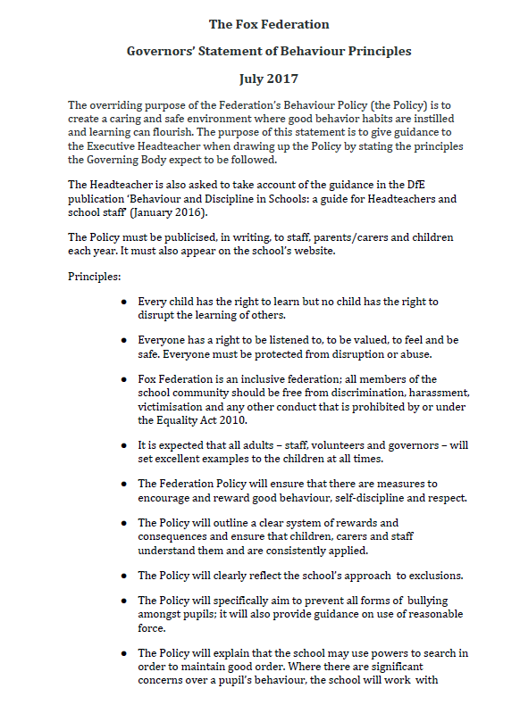

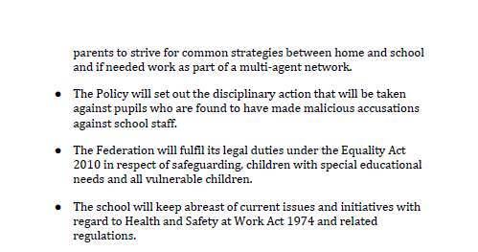

Appendix 2:

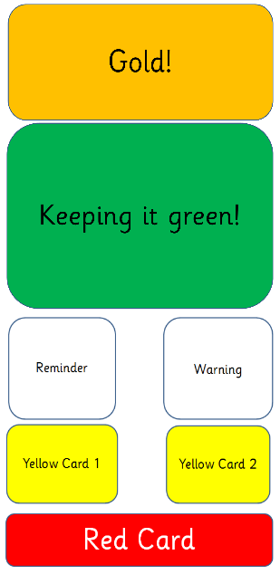
Notes
- All children start the day on green.
- Children moved up to gold as a reward for positive effort, behaviours, outcomes etc.
- If children are behaving in a way that is not in line with the class contract, they will be moved down to redminder. If this persists they move to warning and then to Yellow Card 1. This involves the child spending a small amount of time in another classroom to allow them to reflect, calm down and prepare to re-enter the lesson. When they come back, they start again on green.
- If negative behaviours continue, a teacher will follow the same structure, but this time a child will move to Yellow Card 2, which results in a visit to a member of the leadership team to discuss their actions and attempt to prevent reaching a red card. Again, when they re-enter the class, they start on green.
- If a child’s behaviour persists, they will be moved to Red Card and removed from the lesson to spend time out of class. This will be with a member of SLT if available.
- If a child receives 3 red cards in a half term they will receive an exclusion. Exclusions increase in length each time a child receives one. The sequence is as follows; half-day internal, full-day internal, full-day external, 2 full-days external, 3 full-days external, 4 full-days external, 5 full-days external. Any other exclusions will result in 5 days external.
- If a child gains more than 15 days of exclusions in a term, or 45 days in a school year, the borough Exclusions Officer will be consulted to advice on whether a permanent exclusion is necessary.

Appendix 3: Exemplar class contract

Class Contract

We agree to…
- respect each other.
- support each other’s learning.
- respect and share school property.
- move around the school sensibly.
- uphold the Fox values (caring, creativity, collaboration, independence).
- try our best.
- enjoy ourselves!

Signatures:

Appendix 4: Individual behaviour plan proforma
Behaviour improvement plan
Name: Class: Date:
Areas of concern:
Key signs of imminent problems:
Calming/avoiding strategies:
Avoidance: Classroom setup/routines
Avoiding strategies:
Resources:
Other people:
Classroom behaviour:
Warnings/alternatives –
Incentives:
Sanctions:
Additional information.

Appendix 7: Red card form

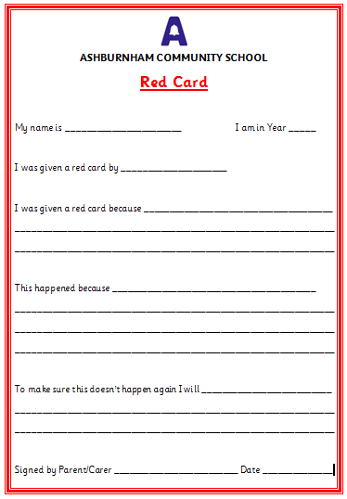

Appendix 6: Restraint incident form


Restraint Incident Form

Name of pupil (s) involved _____________________________

Date incident occurred _____________ Staff involved______________________

Location of incident _____________________________

Behaviour shown | Triggers | Cues
- Biting  - Hitting  - Kicking  - Spitting  - Throwing  - Absconding  - Other | - Change  - Too many demands  - Not getting own way  - Sharing  - Tired  - Hungry  - Hurt  - other | - facial expression  - shouting  - screaming  - repeating  - ignoring  - other
If other please specify; | If other please specify; | If other please specify;
Details of events leading up to the incident | Reason for Intervention (tick) | Description of physical restraint used
 | - Physical safety of the pupil was at risk  - Physical safety of another pupil was at risk  - Physical safety of a member of staff was at risk  - The pupil was attempting to harm him/herself  - Prevent/interrupt absconding  - Behaviour disrupting safe and secure learning environment | - Standing  - Sitting  - Kneeling  - Safe hold  - Restrained in quiet room  - Single person escort  - Two person escort
Steps taken to diffuse the situation (tick) | Pupil(s) response and outcome of the incident | Details of any injury suffered by anyone and damage to property
- Verbal advice and support
- Reassurance
- Calm talking
- Humour
- Distraction
- Step away
- Options offered
- Time out offered
- Negotiation
- Other (specify)
Parent/Carers informed: [] Written [] Telephone [] In person
Form completed by______________________________
Signature______________________
- Any statements from any witnesses (included on separate sheet)

